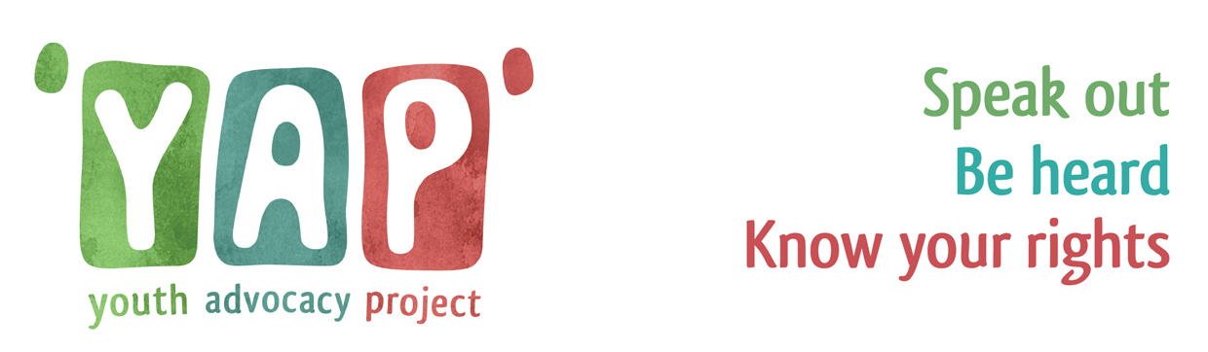
Referral Form

All about you and your family/carers

Name/s |  |  |  | Gender you identify with
DOB/s |  |  |  | School you attend & contact
Home address & Postcode

Best way for us to contact you?  (Mobile number is best) |  |  |  | Do you consent to having an advocate? |  |  | Choose an item.
Ethnicity | Choose an item. |  |  | Disability |  |  | Choose an item.
Do you require an interpreter? | Choose an item. |  |  | If yes, what language?
Do you have any important meetings coming up that you need an advocate to support you at?
 |  | Date | Time |  | Location
Initial Child Protection Conference
Review Children Protection Conference
Me & My World Review
Other state:

Referrer Name |  | Referrer Date | Click here to enter a date.
Referrer’s Contact detail |  |  |  | Pod Number
Who supports you?

Who are the best people to contact who are involved in your care? Eg Parent, social worker, IRO

Role | Name | Contact details | Are you happy for us to contact these people?
What would you like an advocate to do for you?

You have the right to the support from a Youth Advocate if you are;- please pick which one applies to you
Choose an item.

What would you like to get from having an advocate? (please select ‘yes’ to as many as you want or add something that’s not here)
1. | To make sure your views, wishes, opinions and feelings are listened to | Choose an item. | 6. | See more or less of someone | Choose an item.
2. | Your views and feelings are passed onto meetings about your life | Choose an item. | 7. | Get your stuff back | Choose an item.
3. | Tell people you are unhappy about something/make a complaint | Choose an item. | 8. | Get a decision made in your favour | Choose an item.
4. | Confidently speak for yourself in meetings | Choose an item. | 9. | Feel happier about what’s going on | Choose an item.
5. | Change something like your social worker, place to live or carer | Choose an item. | 10. | Other - please describe…

Are there any other important things you want to tell us…

Young Person’s Name: |  | Date
Signature:

Thank you for filling in this form. Please email it to help@bhyap.org.uk. We’ll aim to contact you within five working days.

Advocates provide an open service – ensuring that no information they have or action they take is hidden from the young person. This includes the information that you give us on this referral form.

